EXPERIMENT 2 – Bus Ticket Booking System Prototype (Figma)
AIM
To sketch a simple prototype of a Bus Ticket Booking System using Figma tool.
PROCEDURE
- Open Figma and create a new design file.
- Create a suitable mobile frame for the bus ticket booking application.
- Design the Home Page with application name, From, To, Date, and Search Buses button.
- Design the Bus List Page showing bus names, timings, seat types, and fares.
- Design the Seat Selection Page with available and selected seats.
- Design the Passenger Details Page with name, age, gender, and contact details.
- Design the Payment Page with fare summary and payment methods.
- Design the Booking Confirmation Page with ticket and booking details.
- Use Figma Prototype mode to connect the screens.
- Connect the Home Page to the Bus List Page using Search Buses.
- Connect the Bus List Page to the Seat Selection Page.
- Connect the Seat Selection Page to Passenger Details using Proceed.
- Connect Passenger Details to Payment using Continue.
- Connect Payment to Booking Confirmation using Pay.
- Test the complete navigation and verify that the prototype works correctly.
- Review the prototype and finalize the design.
OUTPUT:
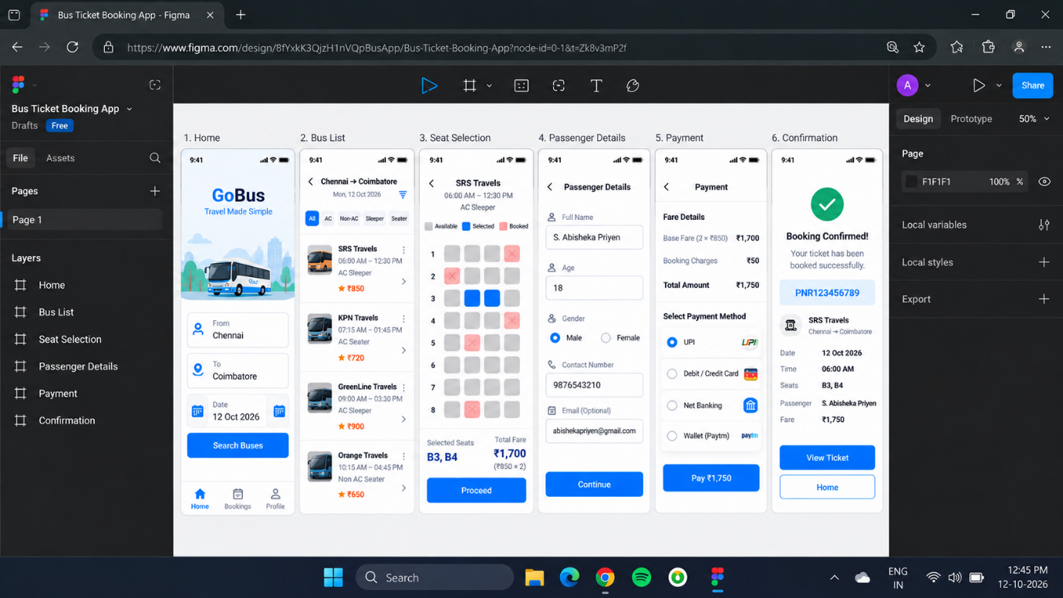

RESULT:
Thus, the prototype of a Bus Ticket Booking System was created successfully using Figma tool.

